IAIR Annual Conference and AGM 2023
“Digitalization/IT Developments in the Insolvency World”
18th – 21st September 2023
In Belgrade, Serbia
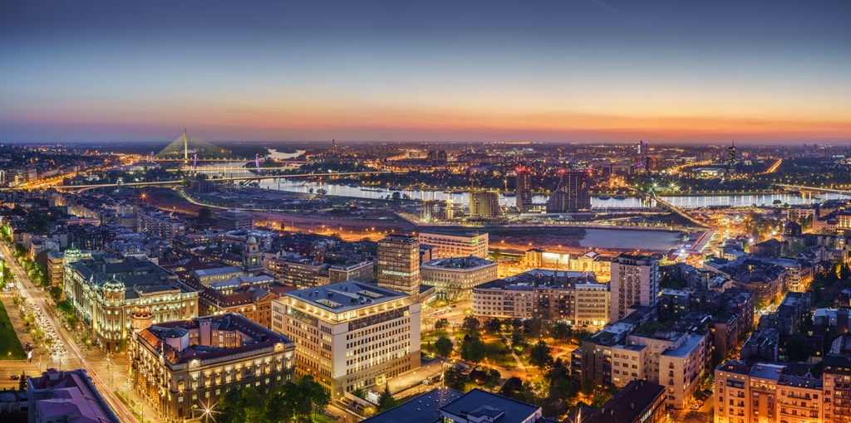

Day 1 – Monday 18 September
Time (UK time) | Session Topic | Venue
14.00-17.30 | Registration and networking opportunity | Metropole Palace Hotel, reception area
16.00-17.30 | Executive Committee meeting  (Executive Committee members only) | Metropole Palace Hotel  Room to be determined
18.00-20.00 | Drinks Reception and Formal Welcome to Belgrade & the IAIR 2023 Conference  (Drinks with Hors d'oeuvres) | Metropole Palace Hotel, roof top terrace
20.00-onwards | Free session

Day 2 – Tuesday 19 September
Time | Session topic | Speaker | Venue
08.30-09.00 | Registration and morning coffee/tea |  | Metropole Palace Hotel, reception area
Session 1  09.00-09.05 | Welcome and conference opening | IAIR Executive Director & IAIR Chair | Metropole Palace Hotel Ivo Andric Conference Room
Session 2  09.05-09.30 | Plenary 1  Keynote speech | Keynote speaker to be determined | Metropole Palace Hotel Ivo Andric Conference Room
Session 3  09.30-10.45 | Plenary 2  Round Table - Member updates  An opportunity for all members to update delegates on their key achievements and challenges | All participants | Metropole Palace Hotel Ivo Andric Conference Room
Session 4  10.45-11.30 | Morning break and official photograph |  | Metropole Palace Hotel – Location to be determined
Session 5  11.30-12.00 | Plenary 3 | Branko Radulovic, Full Professor of Economics and Economic Analysis of Law, Faculty of Law,  University of Belgrade | Metropole Palace Hotel Ivo Andric Conference Room
Session 6  12.00-12.30 | Plenary 4  Driving contemporary regulation through data and digitalization | Tim Beresford, Chief Executive, AFSA, Australia | Metropole Palace Hotel Ivo Andric Conference Room
12.30-13.30 | Lunch |  | Metropole Palace Hotel Restaurant

Session 7  13.30-14.30 | Workshops 1 – Funding models |  | Nikola Tesla Conference Room and  To be determined
 | - Corporate  Zero Asset Company Insolvency  Dean Beale, Inspector General and Chief Executive, The Insolvency Service, United Kingdom | - Personal  Low-income Personal insolvency  Trevor Noonan, Head of the Case Management Division in the Insolvency Service of Ireland;  Karen Seebaran-Blondet, Supervisor of Insolvency, Office of the Supervisor of Insolvency, Trinidad and Tobago  Ester O. Springer  Supervisor of Insolvency, Barbados
14.30-14.50 | Afternoon coffee/tea |  | Metropole Palace Hotel Ivo Andric Conference Room
Session 8  14.50 – 15.25 | Plenary 5  Converting a paper-based process debtor application process to an online system complete with an integrated contribution process and credit check | John Cook, Depute Accountant in Bankruptcy, Accountant in Bankruptcy, Scotland | Metropole Palace Hotel Ivo Andric Conference Room
Session 9  15.25 – 16.00 | Plenary 6  Crypto restructurings/ insolvencies in Singapore | Francis Ng, Official Assignee and Public Trustee, Ministry of Law, Singapore | Metropole Palace Hotel Ivo Andric Conference Room
Session 10  16.00 – 16.30 | Plenary 7  FTX | Speaker to be determined
16.30– 18.15 | Free session
18.15 – 18.30 | Delegates meet in the Metropole Palace Hotel lobby
18.30-22.00 | Formal Conference Dinner - To be determined

Day 3 – Wednesday 20 September
Time | Session topic | Speaker | Venue
08.45-09.00 | Morning coffee/tea and networking |  | Metropole Palace Hotel Ivo Andric Conference Room
Session 11  09.00-09.05 | Welcome | IAIR Chair | Metropole Palace Hotel Ivo Andric Conference Room
Session 12  09.05-9.35 | Plenary 8  IBC 21: A Nextgen IT Platform for Insolvency Regime in India | Mr. Abhishek Mittapally, Manager, IBBI | Metropole Palace Hotel Ivo Andric Conference Room
Session 13  9.35-10.05 | Plenary 9  Statement of affairs and information collection | Russell Fildes, National Manager, New Zealand Insolvency & Trustee Service | Metropole Palace Hotel Ivo Andric Conference Room
Session 14  10.05-10.35 | Plenary 10  Directors’ Disqualification Project Update | Cathy Shivan,  Director of Insolvency Supervision, Corporate Enforcement Authority, Ireland  Angela Crossley, Strategy, Policy and Analysis Director, The Insolvency Service, United Kingdom | Metropole Palace Hotel Ivo Andric Conference Room
10.35-10.55 | Morning tea/coffee break |  | Metropole Palace Hotel Ivo Andric Conference Room
Session 15  10.55 – 11.30 | Plenary 11 | IAIR Diversity Project Members  External Speaker to be confirmed | Metropole Palace Hotel Ivo Andric Conference Room
Session 16  11.30-12.00 | Plenary 12  Data, IT technology, AI, Risk and predictive modelling – Polish Experience (to be confirmed) | Judge Kamila Sawicka, Chief Specialist Commercial Law Department, Poland  Speaker to be determined | Metropole Palace Hotel Ivo Andric Conference Room

12.00 - 13.10 | Lunch |  | Metropole Palace Hotel Restaurant
Session 17  13.10-14.10 | Workshops 2 |  | Nikola Tesla Conference Room and  To be determined
 | - Early Warning Tools  Marina Vatanen, Senior Bankruptcy Lawyer, the Office of Bankruptcy Ombudsman, Finland  David Hegarty, Director of Legal and Policy, Corporate Enforcement Authority, Ireland  Michael Dillon, Director of Legal, Corporate Enforcement Authority, Ireland | - Implementing the Diversity Agenda  IAIR Diversity Project Members
14.10-14.30 | Afternoon coffee/tea |  | Metropole Palace Main Conference Room
Session 18  14.30 - 15.00 | Plenary 13  Data and Digitalization: Policy Considerations for Insolvency Regulation in Emerging Economies | Catherine Bridge Zoller, Senior Counsel, European Bank for Reconstruction & Development (EBRD) | Metropole Palace Hotel Ivo Andric Conference Room
Session 19  15.00–15.30 | Plenary 14  Trustee and Debtor Risk Factors and AI Detection | Elisabeth Lang  Superintendent of Bankruptcy, Office of the Superintendent of Bankruptcy, Canada | Metropole Palace Hotel Ivo Andric Conference Room
Session 20  15.30–16.30 | Annual General Meeting  (IAIR Members only)
16.30 -19.00 | Free session
19.00 – 19.15 | Meeting in the Metropole Palace lobby and organized transportation to Informal dinner
19.30- 22.30 | Informal Dinner – To be determined

Day 4 – Thursday 21 September
Time | Session topic | Speaker | Venue
08.45-09.00 | Morning coffee/tea and networking |  | Metropole Palace Hotel Ivo Andric Conference Room
Session 21  09.00-09.05 | Welcome | IAIR Chair | Metropole Palace Hotel Ivo Andric Conference Room
Session 22  09.05-09.35 | Plenary 15  Electronic registry of Insolvency practitioners - findings | Ardita Buna, Director, National Insolvency Agency, Albania  Speaker to be determined | Metropole Palace Hotel Ivo Andric Conference Room
Session 23  09.35-10.05 | Plenary 16  World Bank Update | Speaker to be determined | Metropole Palace Hotel Ivo Andric Conference Room
Session 24  10.05-10.35 | Plenary 17  IMF Update | Speaker to be determined | Metropole Palace Hotel Ivo Andric Conference Room
10.35-11.00 | Morning break and networking |  | Metropole Palace Hotel Ivo Andric Conference Room
Session 25  11.00-11.30 | Plenary 18 |  | Metropole Palace Hotel Ivo Andric Conference Room
Session 26  11.30-12.40 | Plenary 19  Presentations from the New Members of IAIR:  - Abu Dhabi  - Barbados  - Kenya | Wicki Andersen, Legal Director, Registration Authority, Abu Dhabi Global Market, UAE  Ester O. Springer  Supervisor of Insolvency, Barbados  Speaker to be determined | Metropole Palace Hotel Ivo Andric Conference Room
Session 27  12.40-13.00 | Handover to New IAIR Chair: Presentation by the host of IAIR 2023  Formal handling over of the IAIR Flag  Formal Closing of the Conference | Country to be determined | Metropole Palace Hotel Ivo Andric Conference Room
13.00 -14.00 | Lunch buffet |  | Metropole Palace Hotel Main Restaurant
14.00 | Delegates depart or are free to explore Belgrade and the surrounding area.

